**Project on mounting EFS to Ec2 by using NFS CLIENT…**

**Prerequisites Required**:-

1. Required VPC with two different zone subnets like **ap-south-a** & **ap-south-b**…and ensure that **dns-hostname** and **dns-resolution** should be enable while creating VPC…
2. Create two instances with diferent zone but with same VPC…
3. Create one security group for efs purpose and set both inbound and outbound rules for nfs mounting..
4. And install NFS client packages to both ec2 instancess…to mount purpose …
5. Created two ec-instances with different availability zones and with same default vpc….

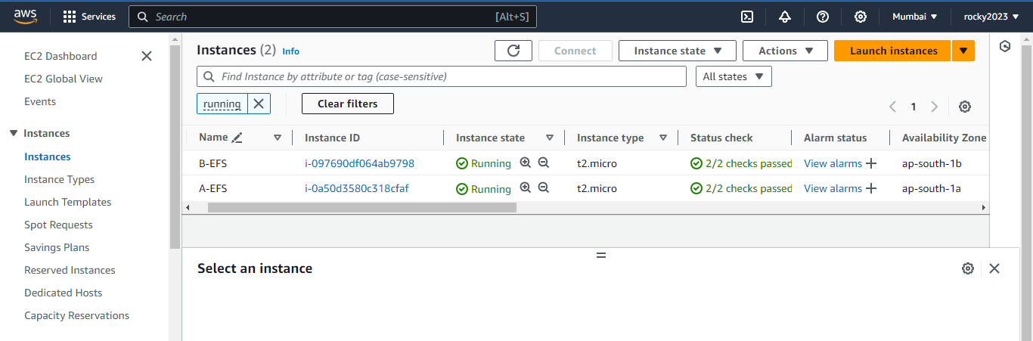

1. Edit inbound rules for both ec2 –instances to allow NFS port 2049 to anywhere…

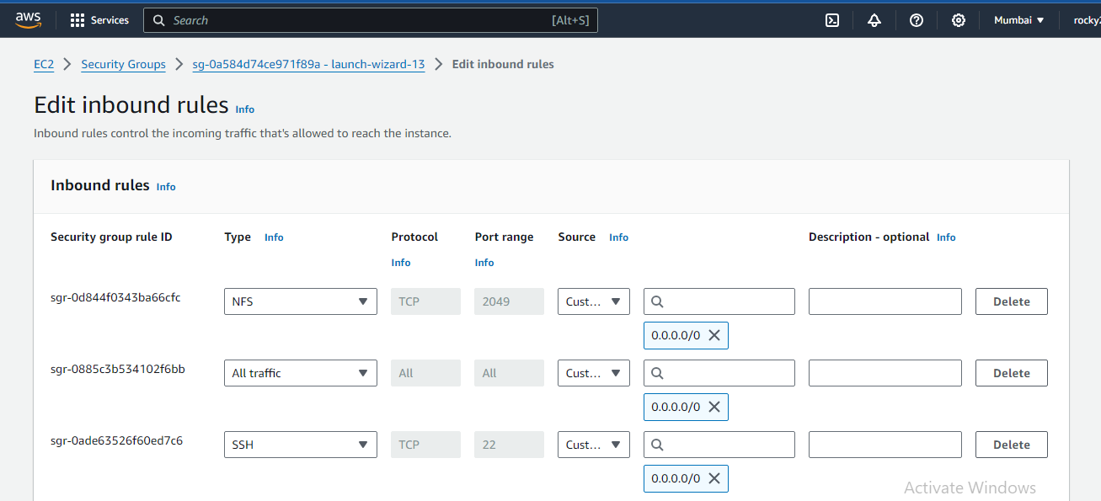

1. Created **VPC** with two difeerent zone subnets and with enabling the both **DNS-hostname** & **resolution**…below image shown clearly…

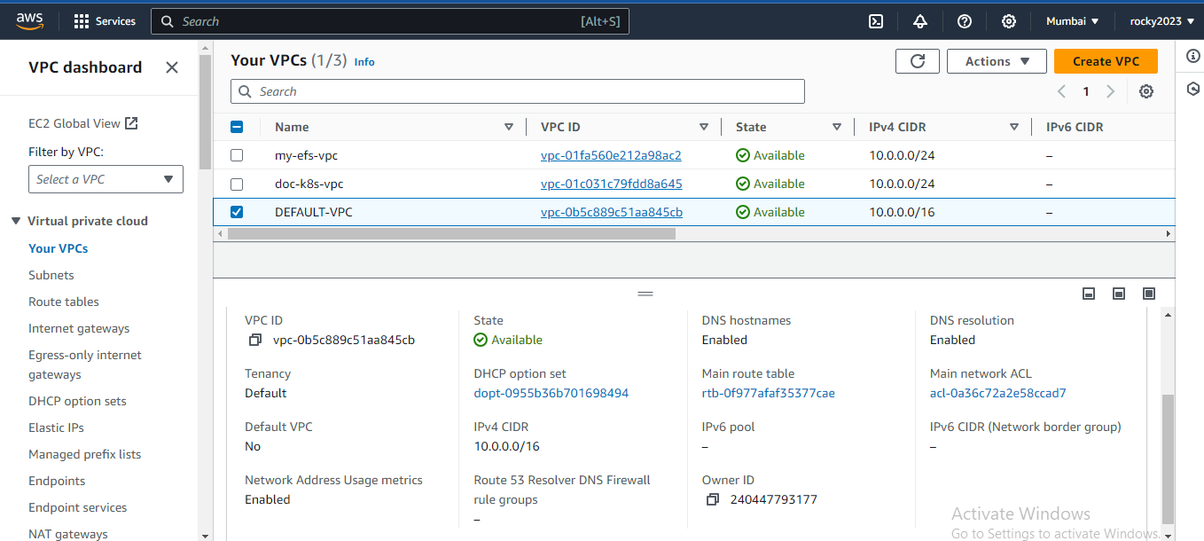

1. Created one dedicated security group for EFS purpose below image shown…

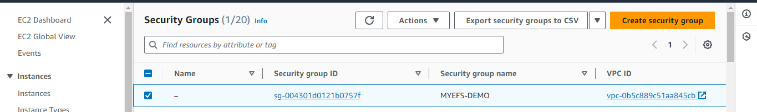

1. Set outbound rules for created security group to allow NFS with prot no:2049 and DNS(TCP) port no:-53 with custom tcp anywhere….

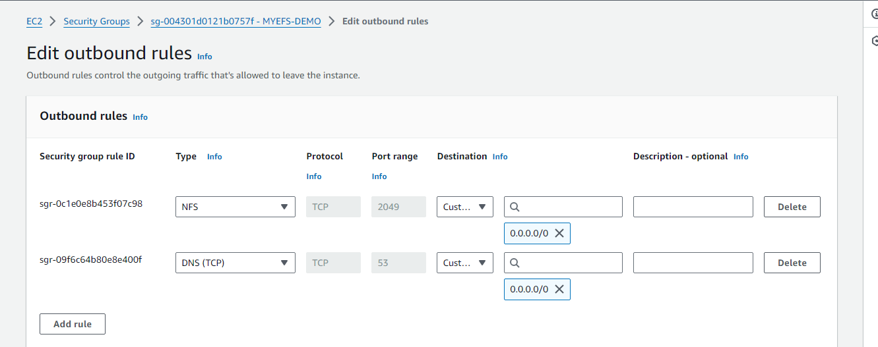

1. Created new EFS filesystem with default VPC..below image shown and select customize to change some requiremnts….

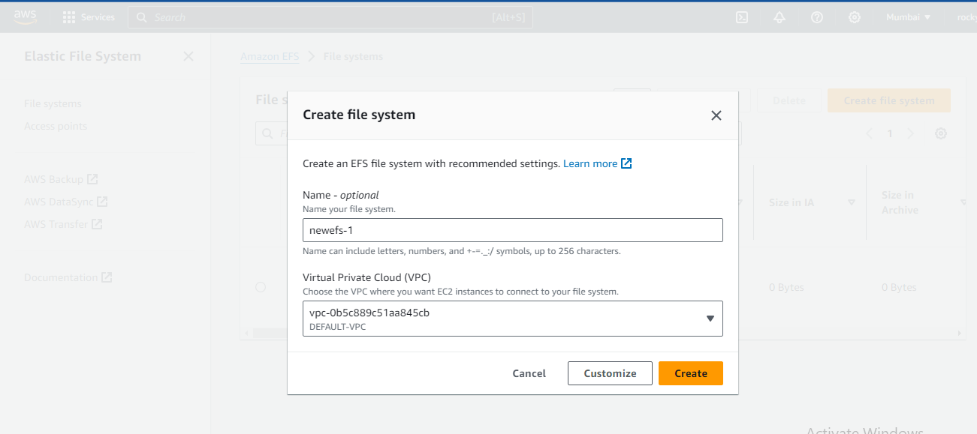

1. File system selected regional because we are working on differentzone so selected..

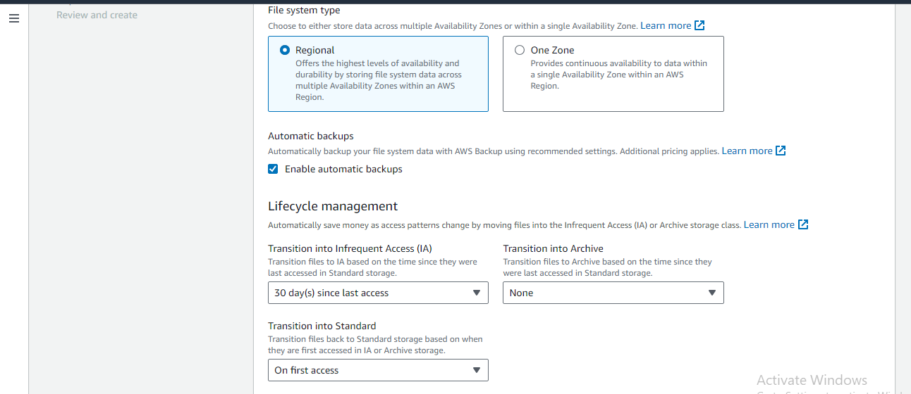

1. Here performance settings selected Bursting…and select next…

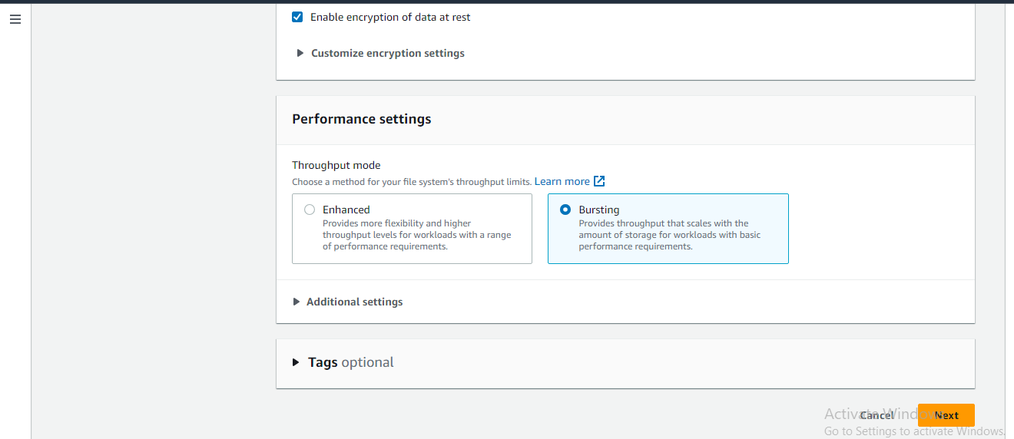

1. Here in mount targets selected defaultvpc & selected both AZ security groups that shown in below image…and created the filesystem…

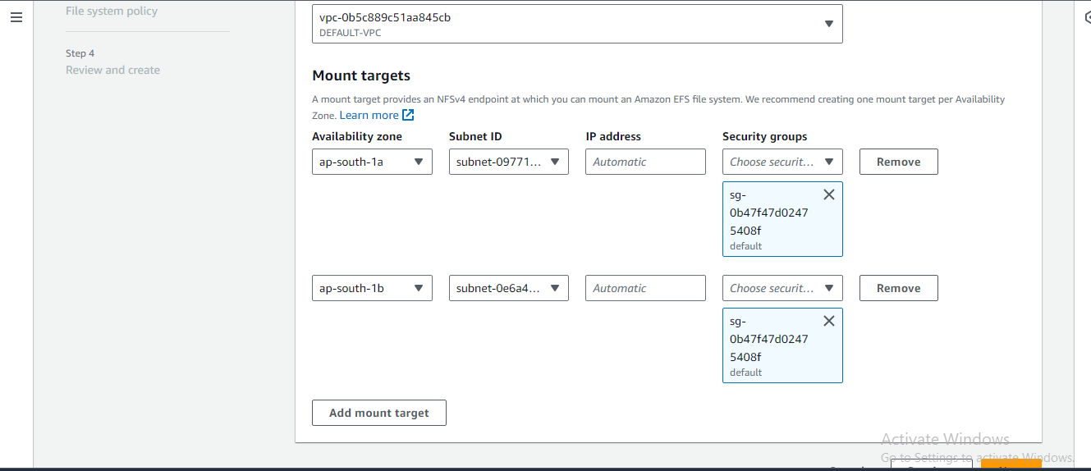

1. Next installed the NFS utilities…with mentioned commands…

A) sudo apt update

B) sudo apt install nfs-common

C) Enable DNS Support in VPC

Go to the AWS VPC console.

Select your VPC.

Ensure "DNS resolution" and "DNS hostnames" are enabled.

D) Check Security Groups and Network ACLs

Make sure your security groups allow outbound traffic on port 53 (DNS)

Verify that your network ACLs allow DNS traffic

1. Next connect first AZ-A ec instance..
2. Switch to superuser with SUDO SU
3. And created directories like newdir1 in ec2 AZ-A and EC2-B created newdir2 like these created in both instances and mounted with below commands…
4. Next mount this with using NFS client command below shown in image do some changes here in the end of the command replace efs with ur created directory newdir1 and newdir2 for both ec2 instance to use this command for mounting purpose…

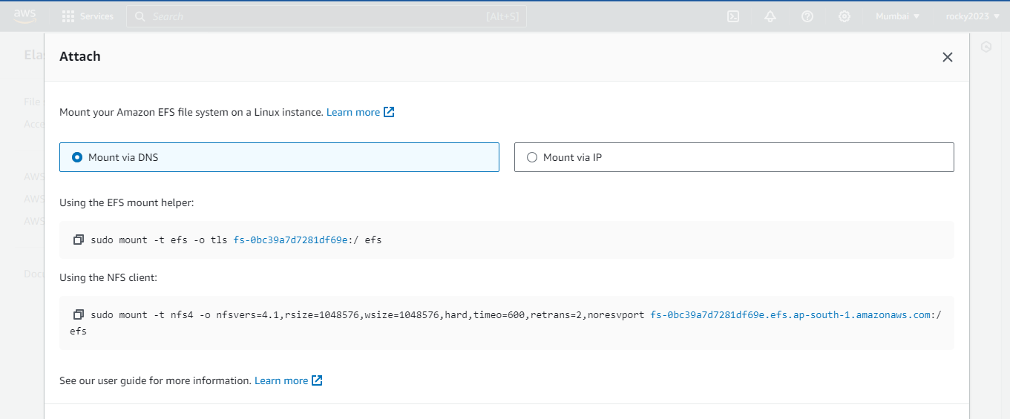

1. Below image shown that mounted and switched to the created directory created file is demo.txt that shown in image and also shows that demo.txt1 created it on another ec2instance means both are mounted …below image shown AZ-A mounted….

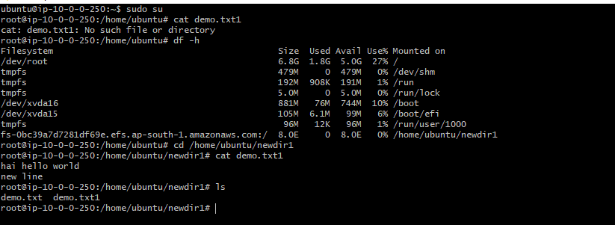

13 ) Below image shown that mounted on AZ-B

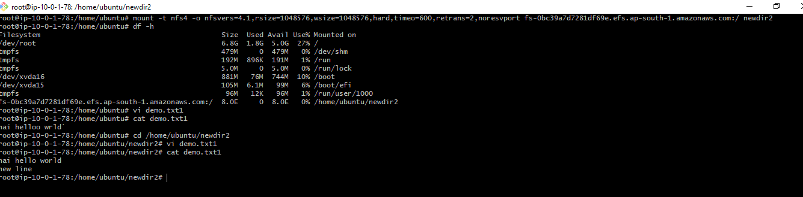

14)Below image shows that files created in AZ-A lists here in AZ-B and what ever created her lists in AZ-A…

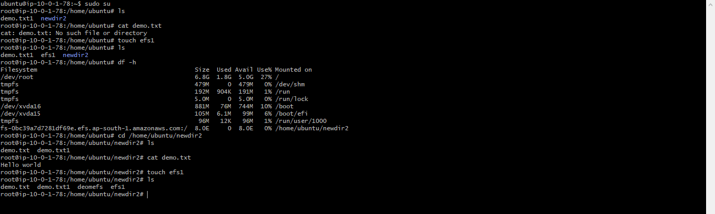

15) Below image shows that efs1 file created in AZ-B and it lists in AZ-A instance….both ec2 instances mounted …

